Name: K.Poorna chandu
Reg No: 192312585
Subject: ECA56 –5G / 6G Communication Systems

Experiment 11: Implementation of IoT-based Smart Agriculture using MATLAB
Aim: To design and simulate an IoT-based smart agriculture system using MATLAB by
monitoring soil moisture levels, controlling water pump status (ON/OFF), and evaluating
irrigation efficiency for optimized water resource management.
Objective 1:
Program:
clc; clear; close all;
% Simulated soil moisture data (%)
time = 1:10;
soil_moisture = [30 35 28 25 20 18 22 30 40 45];
% Threshold for irrigation
threshold = 40;
figure
% -------- Graph 1: Soil Moisture Variation --------
subplot(2,1,1)
plot(time, soil_moisture, '-o', 'LineWidth', 2)
title('Soil Moisture Monitoring in IoT Smart Agriculture')
xlabel('Time (Hours)')
ylabel('Soil Moisture (%)')

grid on
hold on
yline(threshold,'r--','Threshold')
% -------- Graph 2: Moisture Status (Dry/Wet Level) --------
status = soil_moisture >= threshold;
subplot(2,1,2)
stem(time, status, 'filled', 'LineWidth', 2)
title('Soil Condition Status (1=Wet, 0=Dry)')
xlabel('Time (Hours)')
ylabel('Status')
grid on

Output:
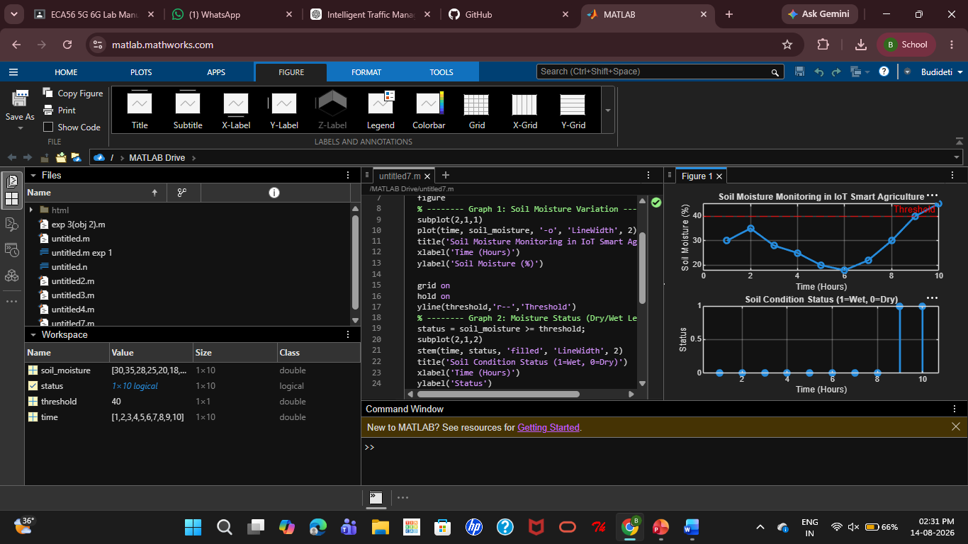
Objective 2:
Program:
clc; clear; close all;
% Simulated soil moisture (%)
time = 1:10;
soil_moisture = [30 35 28 25 20 18 22 30 40 45];
% Threshold level
threshold = 40;

% Pump control logic (1 = ON, 0 = OFF)
pump_status = soil_moisture < threshold;
figure
% -------- Graph 1: Soil Moisture vs Pump Status --------
subplot(2,1,1)
plot(time, soil_moisture, '-o','LineWidth',2)
title('Soil Moisture vs Pump Control')
xlabel('Time (Hours)')
ylabel('Soil Moisture (%)')
grid on
hold on
yline(threshold,'r--','Threshold')
% -------- Graph 2: Pump Status (ON/OFF) --------
subplot(2,1,2)
stem(time, pump_status, 'filled','LineWidth',2)
title('Water Pump Status (1=ON, 0=OFF)')
xlabel('Time (Hours)')
ylabel('Pump Status')
grid on
Output:
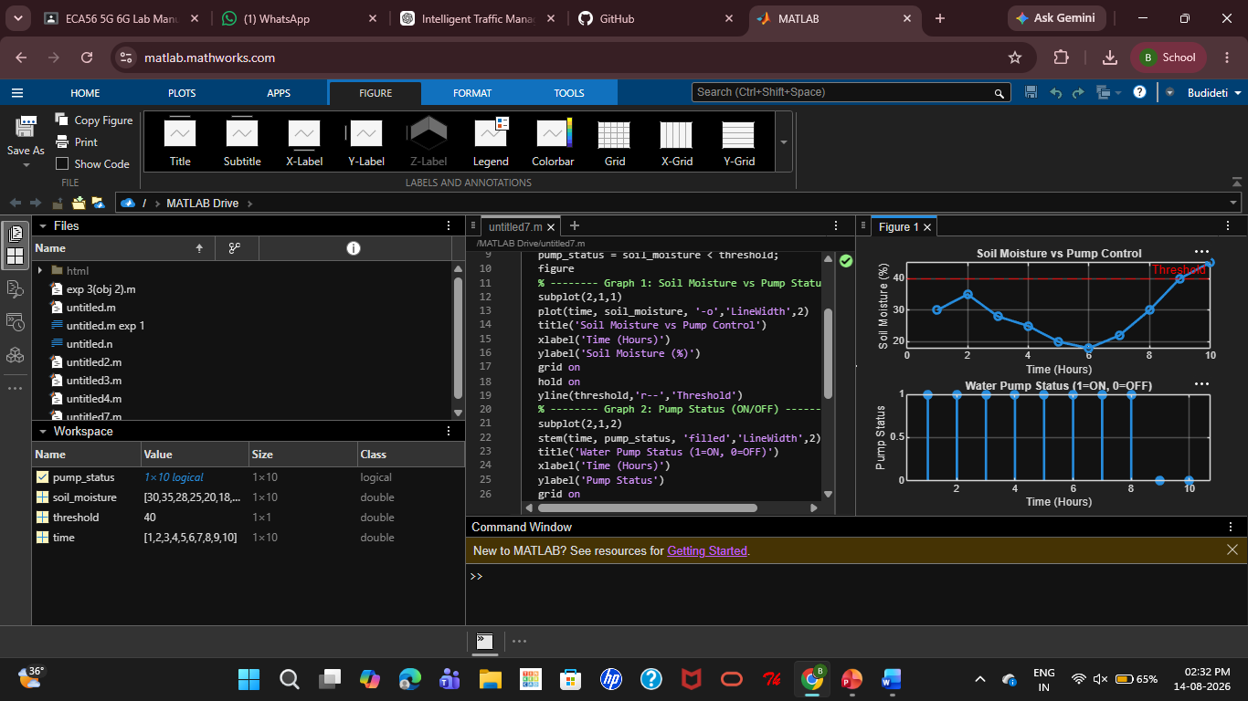
Objective 3:
MATLAB Code:
clc; clear; close all;
% Simulated soil moisture data (%)
time = 1:10;
soil_moisture = [30 35 28 25 20 18 22 30 40 45];
% Threshold level
threshold = 40;
% Irrigation efficiency calculation (%)
efficiency = (soil_moisture ./ threshold) * 100;
efficiency(efficiency > 100) = 100; % limit to 100%
figure
% -------- Graph 1: Soil Moisture vs Efficiency --------
subplot(2,1,1)
plot(time, soil_moisture, '-o','LineWidth',2)
title('Soil Moisture Variation')
xlabel('Time (Hours)')
ylabel('Soil Moisture (%)')
grid on
hold on
yline(threshold,'r--','Threshold')
% -------- Graph 2: Irrigation Efficiency --------
subplot(2,1,2)
plot(time, efficiency, '-s','LineWidth',2)
title('Irrigation Efficiency (%) in Smart Agriculture')
xlabel('Time (Hours)')
ylabel('Efficiency (%)')
grid on
Output:
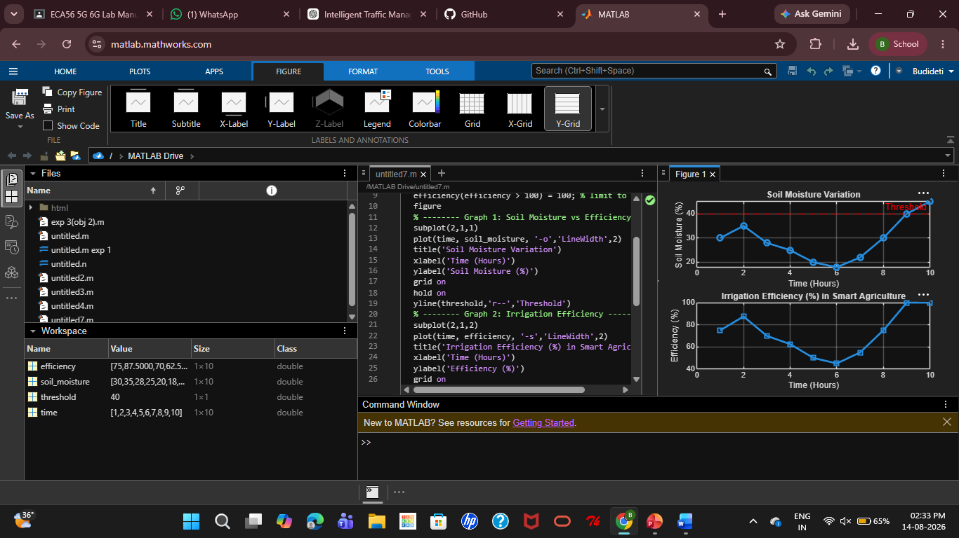
Result:
The IoT-based Smart Agriculture system was successfully simulated in MATLAB. Soil moisture was monitored, the water pump was automatically controlled based on the threshold, and irrigation efficiency was evaluated for effective water management.

